1. **Report Title - BEYOND THE GAMING CONSOLE**
2. **Introduction**
3. **Purpose of the Project Analysis**

The purpose of this project analysis is to gain comprehensive insights into the gaming industry's performance of 16598 games released by 576 companies. Through data visualization, we aim to explore historical sales trends, understand the influence of platforms, genres, and publishers, and identify regional market dynamics. This analysis will inform strategic decisions for companies operating in the gaming sector, uncover opportunities for growth, and help optimize market presence on a global scale.

1. **Describe the dataset you have selected**

* This dataset contains a list of video games with sales greater than 100,000 copies. It was generated by a scrape of [vgchartz.com](http://www.vgchartz.com/).
* <https://www.kaggle.com/datasets/gregorut/videogamesales>
* This Videogame dataset was extracted from the website called – Kaggle.com
* This dataset has the following fields in it
* Rank
* Name
* Platform
* Year
* Genre
* Publisher
* NA_sales
* EU_sales
* JP_sales
* Other_sales
* Global_sales
* This dataset has 16598 number of rows

1. **Analysis Methodology followed:**
2. The analytical tool used for this project “Beyond The Gaming Console” to create visualizations in the form of dashboards is Power BI which is a data visualization software that allows users to create interactive dashboards and reports. It is known for its ease of use and its ability to produce visually appealing and informative data visualizations.
3. **Visualizations Process:**

By connecting Power BI to an Excel spreadsheet containing videogame sales data. After the data is connected, it is cleaned, made compatible with Power BI for analysis, and errors are eliminated. Tables, charts, and maps are just a few of the many visualizations that Power BI provides. By dragging and dropping fields from the data pane to the visualization pane, visualizations could be created. changed the chart type, axis label, and colors to personalize the visualizations and give them a deeper meaning.

**Screenshot of the Visualization from Dashboard:**

**This visualization gives info on the sum of sales in NA, JP, EU, and other sales**

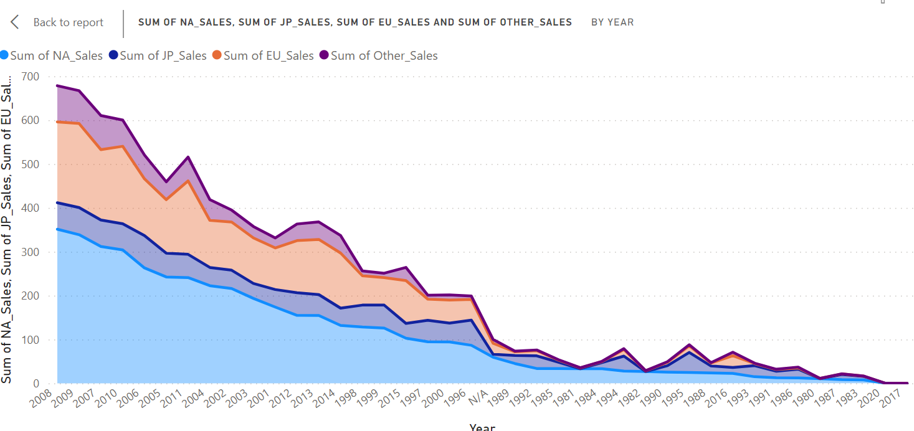

**Visualization of TOP 10 Publishers of all time**

**C. Screenshots of the Final 3 Dashboards**

**Sales By Region and Platform Trends**

**Publisher performance and market share**

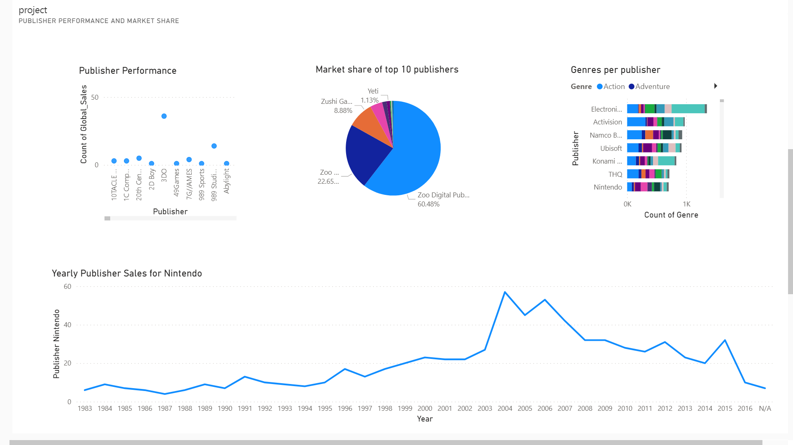

**Regional Market Analysis**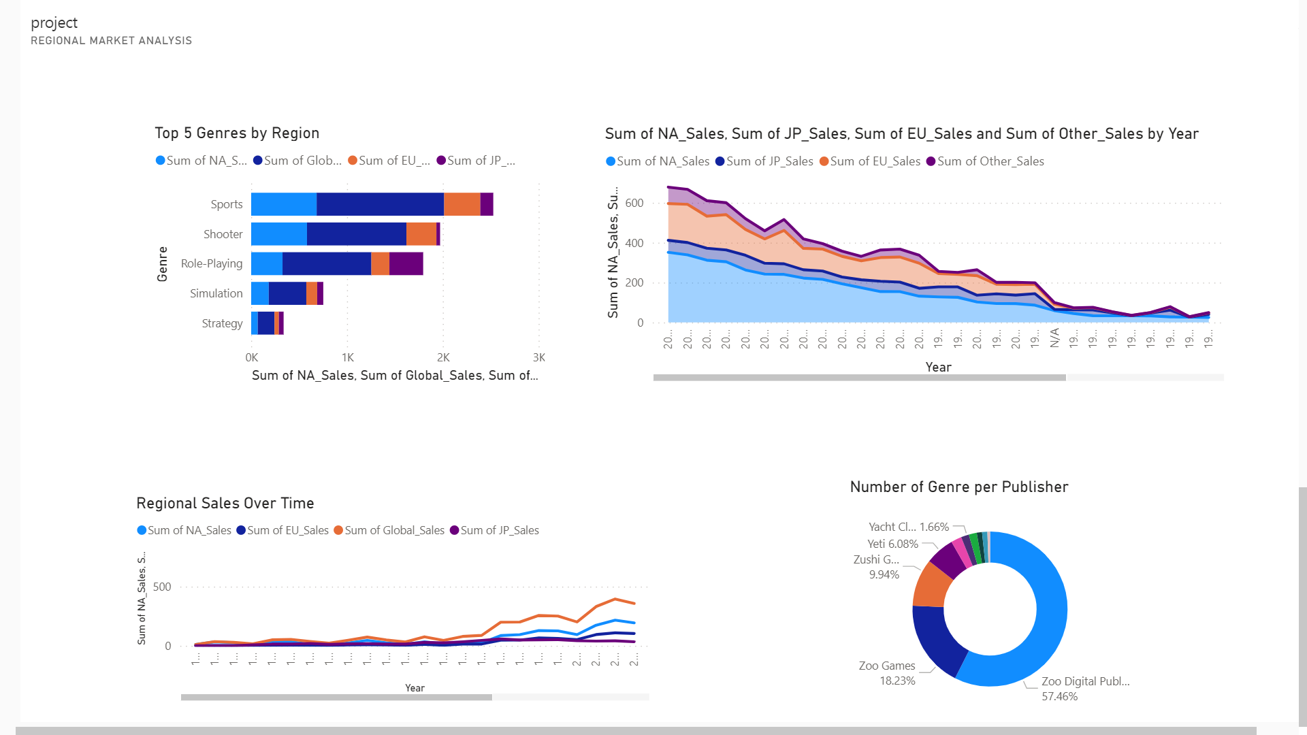

1. **Analysis Results:**

|  |  |  |
| --- | --- | --- |
| **Dashboard1- Sales by region and platform trends** | | |
| Positive Insights | Negative Insights | Any other analysis comment |
| From the stacked column chart “Top 10 games by global scale”, it is noted that. On a global scale games related to sports and action-adventure are topping the chart with WII sports and Grand Theft Auto V with 82.74 and 52.92 in millions | Sales in Japan and other parts of the world are much less compared to the NA and EU region | To create games that appeal to Japanese gamers more studies can be done to design and produce the games according to their taste. |
| The clustered column chart “TOP 5 PLATFORMS OF GLOBAL SALES WITH SALE CONTRIBUTION FROM EACH REGION” shows that sales from the NA region have the highest sales for all the top 5 platforms. | Japan contributes less than 4% for the top 3 highest earning games as per revenue |  |
| Area chart “Sales per platform” gives information about the top 2 platforms performing well according to the sum of global sales are PS2 with 1255.64 AND X360 with 979.96 in millions dominating the industry by capturing the significant market share | Platform DS being in the 5th position according to global sales still holds the highest sales for the JP region with 175.57 million |  |
| Among all the gaming regions it is found that the major source of revenue for the top 5 performing games came from the NA and EU region |  |  |

|  |  |  |
| --- | --- | --- |
| **Dashboard2- Publisher performance and market share** | | |
| **Positive Insights** | **Negative Insights** | **Any other analysis comment** |
| In total worldwide sales, Nintendo is the publisher with the largest market share. Of the publishers in the top 10, Nintendo accounts for 28.55% of worldwide sales. | It is observed that Publisher Nintendo releases have decreased consistently from their peak in 2004 and have seen a slight rise in 2015 and decrease to their all-time low in 2016 | High Competition among small publishers may lead to reduced overall market share |
| Over time, Nintendo maintained its presence in the global market. Nintendo game releases grew steadily over the years, reaching a peak in 2004 with the release of 57 titles. |  |  |
| Games in at least 12 genres were released by the top 10 publishers in the world based on Global sales. It makes it clear that a publisher should start focusing on a range of genres to draw in users if it wants to boost sales on a global basis. |  |  |
| Stacked column chart “Publisher Nintendo revenue share by region” It is observed that Publisher has the highest market share in Nintendo. 3 regions contribute to 94% of its total revenue as follows:  NA-45.73%  JP-25.49%  EU-23.44% |  |  |

|  |  |  |
| --- | --- | --- |
| **Dashboard3-Regional market analysis** | | |
| **Positive Insights** | **Negative Insights** | **Any other analysis comment** |
| The stacked bar chart “Top 5 Genres by Region” gives information about the top 5 genres that contributed to the highest revenue from sales. They are:  1. Sports  2. shooter  3. Roleplaying  4. Simulation  5. Strategy | Sales disparities in different regions may indicate potential market gaps |  |
| From the Pie Chart – “Market share by region” tells among all the regions North America and the European Union occupy the top 2 positions in the overall market share with NA-49.27%, EU-27.3%, JP-14.48% and Other_sales-8.95% | Japan and other regions are underperforming requiring adaptation or focused market strategies |  |
| Area chart “Sum of sales from NA, JP, EU and other regions over the years” how the sum of sales from all regions has increased over the years consistently and peaked in 2008 with  NA-351.44 mil  EU-184.40 mil  JP-60.26 mil  Other-82.39 mil |  |  |
| The radar chart “Genre and regional preferences” gives insights about which genre is contributing to what amount of sales in a particular region. Genres having the top 3 positions in sales in all 3 regions are Action, Sports, and shooter.  In NA-region  Action- 877.82  Sports- 683.35  Shooter- 582.59 |  |  |